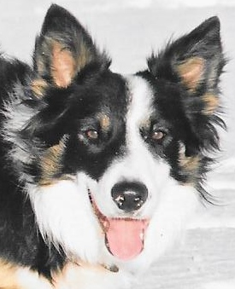
Jimmie’s Farm Novice SDT

OBCC, NEBCA sanctioned

Thursday, October 13, 2022

414 Harts Gravel Road, Elgin, Ontario K0G 1E0

Judge: Lorna Savage

ENTRY FEES: Cdn $/U.S. entries accepted at par (check)

Novice Novice (2 runs) $30/run
OBCC Ribbons to 3rd place, no payback

Pro Novice (2 runs) $35/run
OBCC Ribbons to 3rd place, no payback

* Best Drive and Best Wear prizes in both classes *

Limit 50 runs combined all classes on Scottish Blackface Ewes & lambs
No entries accepted without payment.

Anticipated Order of Classes: PN, NN, NN, PN Start time 9:30 a.m.
(½ hour lunch break)

Entries accepted & treated equally post-marked on or before trial opening date: September 9, 2022
Closing date: September 30, 2022. A draw may be required.

* CAMPING AVAILABLE ON SITE – No Hook ups*
Please email and let me know if you intend to camp Wednesday night

Entries Payable to Janet Fahey:
414 Harts Gravel Road, Elgin, Ontario K0G 1E0
collieaddict@gmail.com / 647-225-3647 (text & email)
Cheque, or Canadian eTransfers (auto deposit)/email entries accepted with payment

- There will be a portable toilet on site and hand wash station.
- Hand sanitizer and wipes will be provided at the toilet.
- Please bring your own food and drink, as no lunch will be provided.
- There will be a handler’s tent.
- All dogs on property must be current on vaccinations and de-worming,
- Handlers should wear clean footwear for biosecurity reasons.
- Covid-19 rules may change by the trial date, but any updates can be found on the local
Leeds-Grenville Health Unit website https://healthunit.org/
or from the trial manager closer to the day.

Jimmie’s Farm Novice SDT – Thursday, October 13, 2022

HANDLER: ………………………………………………………………………………………….….….……...

ADDRESS …………………………………………………………………………………………...….………..

CITY ………………………….………..…...….… PROV/STATE ………….. POSTAL …….……………….

PHONE……………………….……… E-MAIL………………………………………………………………….

NAME OF DOG | A.M. | P.M. | FEE PD
Total $ ___________________
- I will not hold Janet Fahey & Howard Sedding, Jimmie’s Farm, Judge Lorna Savage, the OBCC, or their agents, employees, the trial volunteers, or anyone else connected with the trial responsible for any accident, occurrence or injury to myself or my dogs while participating in this event. I will accept responsibility for and agree to pay damages for any sheep ($350.00 each) or other animals injured by any dog in my care while on farm property. I also agree to follow local Covid-19 requirements* as set out by the Trial Manager. All dogs on property must be current on vaccinations and de-worming. Handlers should wear clean footwear for biosecurity reasons.

Date.......................................

Signature....……………….............................................................................

