OBCC Board Meeting Minutes

November 1, 2017 6:30PM

Attendees:
Tracy Hinton
Werner Reitboeck
Cynthia Palmer
Absent:
Sheri Purcell
Teresa Castonguay (joined at 7pm)

Agenda:

- Approval of the minutes from last board meetings 09/11/17
- Membership
- Financials
- AGM prep
- ranch discussion
- Nominating committee

Minutes Approval
- Review September 11, 2017. Werner approved, Cynthia second
- TO DO- Tracy to send to Rebecca for posting on website

Membership
- 83 members and holding

Treasurer Report
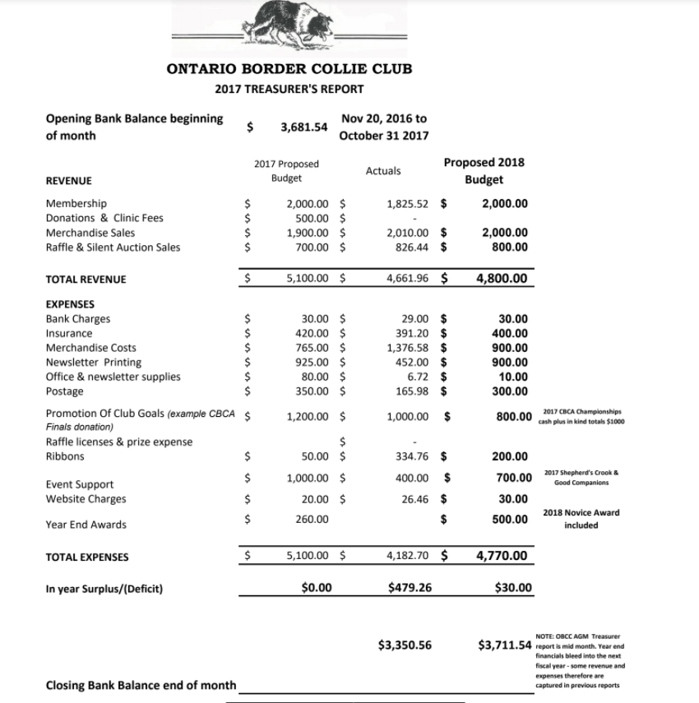
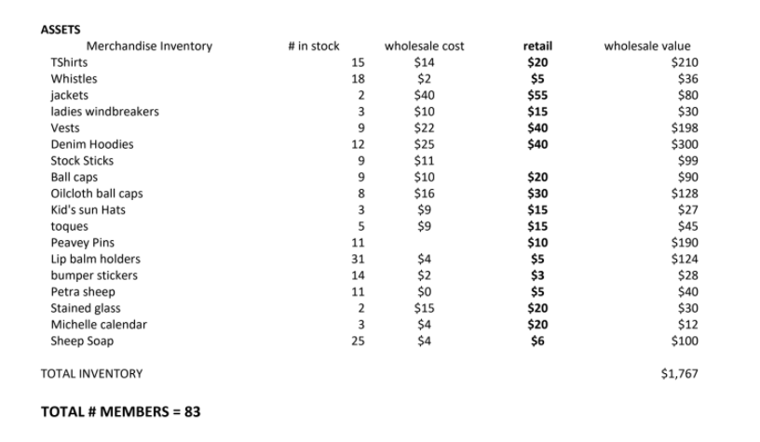
Sheri ordered new ribbons and they are at Cynthia’s house.
Lanyards were not counted.
TO DO:
    - Teresa to get a count
    - We can supply to next years CBCA Canadians

AGM Prep
- Cynthia has all trophy’s except the Open
- Ranch class info has been sent
- Bylaw changes has been sent
- TO DO-
  - Cynthia to get reports from all committees
  - Teresa to send out a reminder email including contact me for online entry and there will be a light lunch served at noon.

Ranch Discussion
- Ranch class information was sent out to members
- At the AGM, we need to put forth all information prior to voting. Cynthia will do this.

Nominating Committee
- The committee is Rebecca and Andrea
- Three people have come forward:
  - Janet Fahey
  - Kim Gretton
  - Rebecca Lawrence
- Two current board members will resign:
  - Sheri Purcell
  - Teresa Castonguay
- TO DO:
  - Prior to the meeting Cynthia will speak to the nominees to confirm.

Other
- none

Next meeting:
- Next meeting will be the AGM on Saturday November 18, 2017 @ 1pm.

Tracy moved to adjourn. Meeting adjourned at 7:10pm.

