OBCC Board Meeting Minutes

March 28, 2018 7:00pm

Attendees:
Kim Gretton
Tracy Hinton
Rebecca Lawrence
Cynthia Palmer
Werner Reitboeck

Agenda:
- Approval of the minutes from last board meeting
- Review TO DO’s from last meeting
- Confirm were we are at on the To Dos
- Learning and Outreach
- Logo
- Most Promising Handler
- Board Goals for 2018

Minutes Approval
- Review January 24, 2018 minutes. Tracy approved, Kim second
- TO DO- Rebecca to Post on website

Committees:
- Newsletter
    - TO DO –
      - Cynthia to send out reminder email regarding the newsletter deadline
      - Schedule a meeting of board and newsletter team to discuss next
- Fundraising
  - Pamela Hall & Janet Fahey
  - TO DO –
    - Agree on the vector file of the logo. Tracy to speak with Pam regarding approval of vector image
    - Tracy feels that we do not need Mia’s approval as we are only aiming to achieve a consistent image & to document colours to be used
    - Werner doesn’t like the green being used currently, Rebecca prefers the black & white
    - Cynthia felt that we could use either colour or black & white as we see fit
    - Tracy will bring it up with Pamela to make sure we have both

- Learning & Outreach
  - Cynthia has not had an opportunity to speak with Sue Jewell as of yet
  - Board is keen on doing something earlier in the season
  - Cynthia thinks that Sue would be amenable to hosting an even in April if the Board could do the organization
  - Lots of members should be interested in a fun run

- Membership
  - Cynthia brought up sending a reminder notice of pay membership
    - Kim will send it out to remind to sign up 20185 membership
  - 3 new people have joined
  - Membership is low but expect it to increase with as the trial season starts soon

- Trials Committee
  - Have received a lot of requests for funding for the board to discuss at the next meeting, final date to submit April 30th
  - Tracy will have a spreadsheet ready for next month
  - Cynthia states that the Trials Committee should submit their recommendations for funding to the Board, to review & approve
  - $800 available to support events
  - Can use the $700 we normally would use for the CBCA Championships if we feel it is needed to support Ontario trials
    - Werner pointed out that we should focus the money on Ontario as the CBCA has the ability to successfully fundraise for the Championships unlike Ontario
    - Cynthia is in agreement, more members could use the money this year in Ontario
    - Can discuss supporting the CBCA Championships at a lesser level to which the Board is in agreement

- Treasurer’s Report
  - Bank balance still the same
  - Cynthia to look at the ribbon inventory, not sure what we have on hand

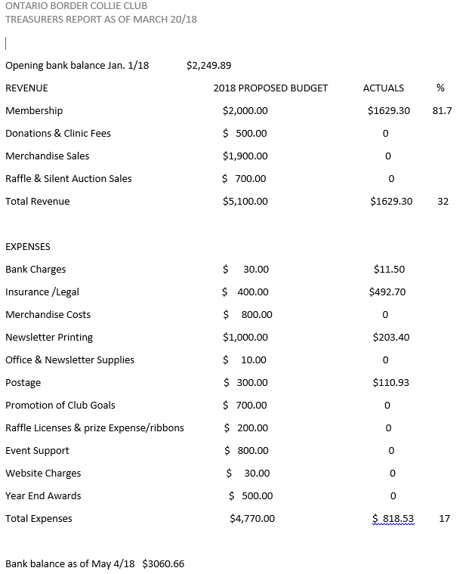

Other
  - Board Goals for 2018
    - To have the logo consistent, mostly completed but Tracy will check with Pamela
    - Encourage a member to have an even to learn about judging (possibly the Sue Jewell event)
      - Rebecca & Kim felt that this would be most beneficial at the start of the trial season versus latter
    - Werner would like to see an event that would teach our members how to be better stock handlers, Rebecca in agreement
      - Most members not from farm stock
      - Have people learn to be the dog
      - Cynthia brought up needing to learn/understand the livestock & how they move, and then how to move them
      - Have an experienced handler direct a dog, and explain how to read the sheep
        - Which one will shed, which will cause trouble
        - More people come to herding because it is a sport & lack the livestock experience
        - Kim points out that Novice handling skills might be hard to teach in Spring with the lack of non-bred ewes
        - Tracy says she will speak with Sheri, the latter has lots of pens & a small working group of un-bred sheep
        - Tracy also suggested that John Palmer might be interested in teaching, Cynthia will speak with him
    - Tracy’s Scott Glen clinic is in line with promoting the club’s goals
      - Hence why it is open to OBCC handlers, helping to support Learning & Outreach for Open handlers along with the September clinic
- Most Promising Novice Handler Award
  - Award recognizes Novice handlers who demonstrate:
    - Good Sportsmanship
    - A willingness to learn and improve
    - Concern for the welfare of stock
    - A willingness to volunteer
    - Aware of and respect for the tradition & history of our sport
  - Need to send out notice to the trialing members, nominations to be submitted by end of August 2018
  - Nominators are asked to briefly describe why the identified member meets the criteria listed above
  - Needs to go into the next newsletter for June
  - What is the Board going to give as a prize?
    - Last time it was a whistle
  - Tracy will handle taking care of the votes are Kim & Rebecca are still eligible for nomination
  - Kim to send an updated membership list to Tracy & Michelle Lawrence before the next newsletter
  - Tracy received an email, USBCHA is requesting local clubs to help support the webcasts for this year’s finals
    - CBCA gave $2,000 last year, does the OBCC wish to also participate?
    - Werner would like to see statistics on how many people actually watched it online & the costs involved. Tracy said approximately $15k for the webcast & she will see if she can obtain viewer ratings
    - Werner pointed out we might not have any available funds to do so if we wish to support our membership more this year
    - Tracy points out that we can decide after the Board reviews the funding requests

Next meeting:
- Next meeting will be Tuesday May 8 @ 7:00pm.
  - TO DO – Tracy to send the meeting

Tracy moved to adjourn. Meeting adjourned at 7:49pm.

